Partial / residual correlation: EURUSD and GBPUSD
Method 07 / daily log returns / leave-currency-out USD factor / Alpari D1 full available history

Study setup
Logical pair: EURUSD , GBPUSD
Broker symbols: EURUSD_i , GBPUSD_i
Snapshot: 2026-11-03_majors_alpari_D1
Timeframe: D1
Matched return window: 1999-01-05 to 2026-11-02 (UTC bar dates)
Matched return count n: 7148
Dropped unfinished last bar dated 2026-11-03 UTC after a tick-volume check against the prior complete day.
USD-strength sign rule: minus log return when USD is the quote (EURUSD, GBPUSD, AUDUSD, NZDUSD); plus log return when USD is the base (USDJPY, USDCHF, USDCAD). EURGBP is never a constituent.
Control z constituents (5): AUDUSD, NZDUSD, USDJPY, USDCHF, USDCAD
z_t = equal-weight mean of those USD-strength returns on the same day
Complete matched rows (Excel): EURUSD-GBPUSD_Partial_D1.xlsx
Complete matched rows (HTML table): EURUSD-GBPUSD_Partial_D1_data.html

Method carried forward
Partial / residual correlation regresses each matched daily log return of close, ln(close_t / close_t-1), on the same leave-currency-out USD strength factor z, then takes Pearson correlation of the two residual series. Quotes are not inverted. z is the equal-weight mean of USD-strength returns from other majors that do not share a non-USD currency with either leg; EURGBP is never a constituent. USD-strength is minus the log return when USD is the quote (EURUSD, GBPUSD, AUDUSD, NZDUSD) and plus the log return when USD is the base (USDJPY, USDCHF, USDCAD). OLS uses an intercept on each leg. rho_partial is symmetric under swap of the two symbols. It describes leftover linear co-movement after removing linear z; it is not a cause, not a lead, and not a trading signal. Daily rows are not independent and residuals are estimated, so the two-sided p-value and Fisher interval are secondary. Same-sample raw Pearson r is a side check only.

Regression on z
leg | intercept_a_or_c | slope_b_or_d | R2
EURUSD | -1.644e-05 | -0.89468472 | 0.54188084
GBPUSD | -3.172e-05 | -0.73951982 | 0.39073173

Results
rho_partial: 0.344146
Two-sided p-value: 6.74005e-198
Approximate 95% Fisher interval: [0.323545, 0.364422]
Same-sample raw Pearson r: 0.641959
rho_partial minus r: -0.297813

Conclusion
Over 7148 matched daily rows for EURUSD and GBPUSD after removing a leave-currency-out USD factor built from 5 constituents, rho_partial is 0.3441 (positive, weak residual linear link in this sample). Approximate 95% Fisher interval: [0.3235, 0.3644]. Same-sample raw Pearson r is 0.6420 (partial minus r = -0.2978). Leg R-squared on z: EURUSD=0.5419, GBPUSD=0.3907. Two-sided p under the usual independent-pairs model is 6.74e-198; residuals are estimated and daily FX rows are linked, so treat p as secondary. This does not establish cause, lead-lag, or a lasting trading rule.

Charts
Daily closes
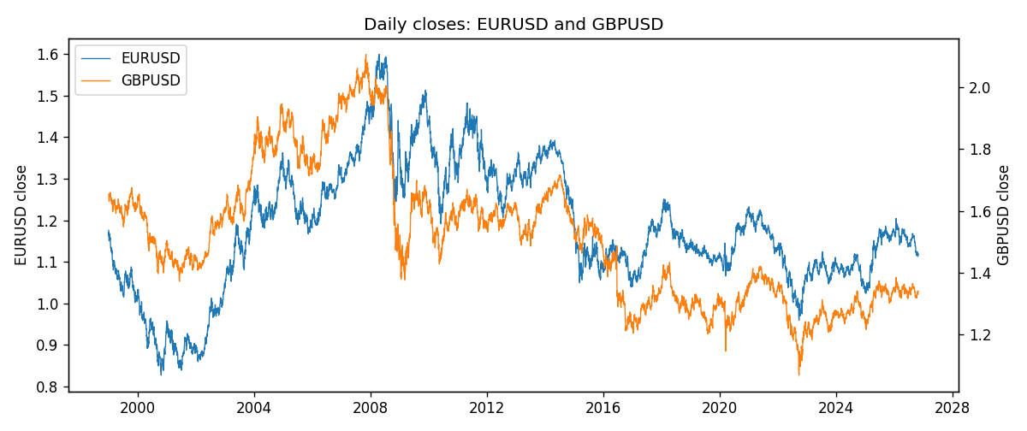
Log returns and control z
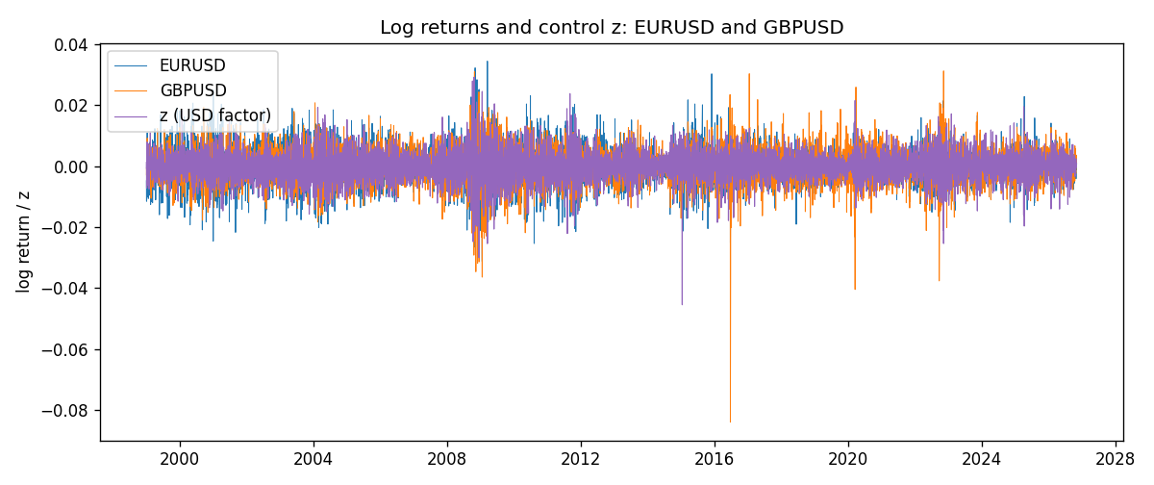
Residual scatter e_x vs e_y
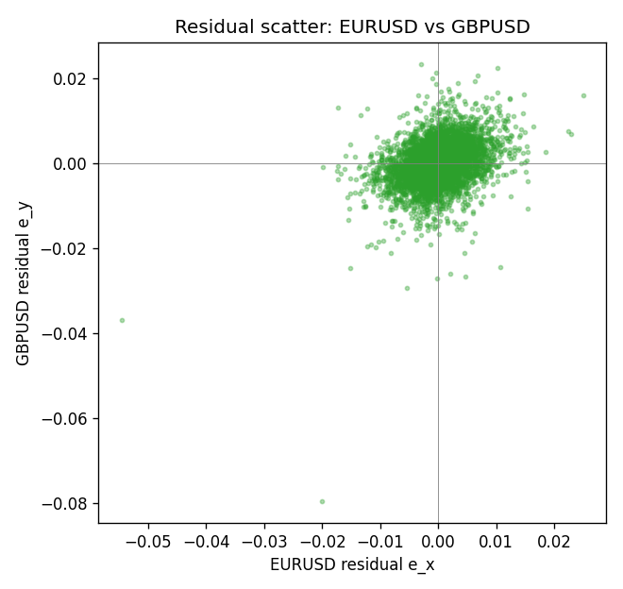

Data report
Every matched row that entered the partial correlation is stored in the sibling Excel workbook named EURUSD-GBPUSD_Partial_D1.xlsx. That file is the complete data archive for redrawing charts. Embedding all rows as a Word table is impractical at this length; the Word file holds the column list, column summaries, and the first and last 15 matched rows.
Columns: time, EURUSD_open, GBPUSD_open, EURUSD_high, GBPUSD_high, EURUSD_low, GBPUSD_low, EURUSD_close, GBPUSD_close, EURUSD_tick_volume, GBPUSD_tick_volume, EURUSD_spread, GBPUSD_spread, EURUSD_real_volume, GBPUSD_real_volume, EURUSD_log_return, GBPUSD_log_return, usd_strength_AUDUSD, usd_strength_NZDUSD, usd_strength_USDJPY, usd_strength_USDCHF, usd_strength_USDCAD, z, EURUSD_fitted, GBPUSD_fitted, EURUSD_resid, GBPUSD_resid
Column summaries (matched calculation rows)
column | count | mean | std | min | 25% | 50% | 75% | max
EURUSD_open | 7148 | 1.1816879 | 0.15074041 | 0.8272 | 1.0863875 | 1.16609 | 1.2942 | 1.5995
GBPUSD_open | 7148 | 1.5147424 | 0.21801364 | 1.06854 | 1.3240425 | 1.50985 | 1.629975 | 2.1066
EURUSD_high | 7148 | 1.1868219 | 0.15134312 | 0.8326 | 1.0904675 | 1.17121 | 1.29957 | 1.6038
GBPUSD_high | 7148 | 1.5210395 | 0.21858109 | 1.08366 | 1.32902 | 1.516685 | 1.6374625 | 2.1161
EURUSD_low | 7148 | 1.1766784 | 0.15005373 | 0.8227 | 1.0822025 | 1.162475 | 1.2886225 | 1.5865
GBPUSD_low | 7148 | 1.5084277 | 0.21724232 | 1.03518 | 1.3186875 | 1.50192 | 1.6233 | 2.0983
EURUSD_close | 7148 | 1.1817317 | 0.15070664 | 0.8267 | 1.0862225 | 1.16602 | 1.2942 | 1.5997
GBPUSD_close | 7148 | 1.5148153 | 0.21797449 | 1.06879 | 1.324035 | 1.50993 | 1.6299575 | 2.1065
EURUSD_tick_volume | 7148 | 103711.54 | 173856.26 | 469 | 9484.75 | 52998 | 99801.75 | 1471626
GBPUSD_tick_volume | 7148 | 95468.138 | 153933.58 | 62 | 10088.75 | 53396.5 | 92022.25 | 1273370
EURUSD_spread | 7148 | 19.246223 | 16.509774 | 0 | 8 | 12 | 20 | 50
GBPUSD_spread | 7148 | 26.846531 | 19.190643 | 0 | 10.75 | 20 | 50 | 50
EURUSD_real_volume | 7148 | 4.0536992e+10 | 1.6733469e+11 | 0 | 0 | 0 | 0 | 3.6149665e+12
GBPUSD_real_volume | 7148 | 3.582457e+09 | 8.4750162e+10 | 0 | 0 | 0 | 0 | 2.4038164e+12
EURUSD_log_return | 7148 | -2.16e-06 | 0.0058013 | -0.03123819 | -0.00324218 | 0 | 0.00325609 | 0.03433183
GBPUSD_log_return | 7148 | -1.992e-05 | 0.00564699 | -0.08388241 | -0.0031217 | 3.426e-05 | 0.00318167 | 0.03112653
usd_strength_AUDUSD | 7148 | -3.157e-05 | 0.00755018 | -0.0806166 | -0.00415111 | -0.00029168 | 0.00385014 | 0.08602525
usd_strength_NZDUSD | 7148 | -1.914e-05 | 0.00764519 | -0.05966839 | -0.004586 | -0.00023666 | 0.00424201 | 0.07027433
usd_strength_USDJPY | 7148 | 5.267e-05 | 0.00620906 | -0.03908203 | -0.00319392 | 0.00012736 | 0.00340928 | 0.05184024
usd_strength_USDCHF | 7148 | -6.945e-05 | 0.0065937 | -0.19545699 | -0.00334697 | 8.15e-05 | 0.00331954 | 0.09051364
usd_strength_USDCAD | 7148 | -1.226e-05 | 0.00514518 | -0.03859748 | -0.00283513 | 4.873e-05 | 0.00272781 | 0.03436319
z | 7148 | -1.595e-05 | 0.00477317 | -0.04542184 | -0.00270013 | -3.31e-06 | 0.00273291 | 0.0291122
EURUSD_fitted | 7148 | -2.16e-06 | 0.00427048 | -0.02606267 | -0.00246153 | -1.348e-05 | 0.00239933 | 0.04062179
GBPUSD_fitted | 7148 | -1.992e-05 | 0.00352985 | -0.02156076 | -0.00205276 | -2.927e-05 | 0.00196508 | 0.03355863
EURUSD_resid | 7148 | -0 | 0.00392658 | -0.05456322 | -0.00211109 | -2.339e-05 | 0.00215662 | 0.02494295
GBPUSD_resid | 7148 | -0 | 0.0044078 | -0.07958938 | -0.00224877 | 7.873e-05 | 0.00240561 | 0.02325349
First 15 matched rows (selected columns)
time | EURUSD_close | GBPUSD_close | EURUSD_log_return | GBPUSD_log_return | z | EURUSD_fitted | GBPUSD_fitted | EURUSD_resid | GBPUSD_resid
1999-01-05 | 1.1758 | 1.6547 | -0.0048360507 | -0.0028966287 | -0.00074078381 | 0.00064633187 | 0.00051610772 | -0.0054823825 | -0.0034127364
1999-01-06 | 1.1623 | 1.6537 | -0.011547966 | -0.00060452184 | 0.0013918159 | -0.0012616725 | -0.001060992 | -0.010286294 | 0.00045647018
1999-01-07 | 1.1712 | 1.6502 | 0.0076280636 | -0.002118709 | -0.00717622 | 0.0064040183 | 0.0052752403 | 0.0012240452 | -0.0073939493
1999-01-08 | 1.1585 | 1.6405 | -0.010902799 | -0.0058954193 | 0.00089151303 | -0.00081405916 | -0.00069100813 | -0.01008874 | -0.0052044111
1999-01-11 | 1.1503 | 1.6312 | -0.007103287 | -0.0056851331 | -0.0063849374 | 0.0056960698 | 0.0046900712 | -0.012799357 | -0.010375204
1999-01-12 | 1.1555 | 1.6349 | 0.0045103728 | 0.0022657001 | 0.0078557747 | -0.0070448776 | -0.0058412176 | 0.01155525 | 0.0081069178
1999-01-13 | 1.1681 | 1.6499 | 0.010845346 | 0.0091330396 | 0.0024568143 | -0.0022145103 | -0.0018485795 | 0.013059857 | 0.010981619
1999-01-14 | 1.1681 | 1.6531 | 0 | 0.0019376331 | 0.0014789102 | -0.0013395944 | -0.0011254 | 0.0013395944 | 0.003063033
1999-01-15 | 1.1563 | 1.6502 | -0.010153245 | -0.0017558204 | 0.0022811788 | -0.0020573719 | -0.0017186935 | -0.0080958731 | -3.7126871e-05
1999-01-18 | 1.1605 | 1.6522 | 0.0036256946 | 0.0012112405 | -0.00024014877 | 0.00019842135 | 0.00014587819 | 0.0034272732 | 0.0010653623
1999-01-19 | 1.1603 | 1.6553 | -0.00017235436 | 0.0018745281 | -0.0024056471 | 0.0021358596 | 0.0017473071 | -0.0023082139 | 0.00012722105
1999-01-20 | 1.1566 | 1.6472 | -0.0031939256 | -0.0049053846 | -0.0018913686 | 0.0016757425 | 0.0013669879 | -0.0048696681 | -0.0062723725
1999-01-21 | 1.1601 | 1.6524 | 0.0030215416 | 0.0031518998 | -0.0008965964 | 0.00078573502 | 0.00063133422 | 0.0022358065 | 0.0025205656
1999-01-22 | 1.1587 | 1.6565 | -0.0012075213 | 0.0024781662 | 0.0065413802 | -0.005868909 | -0.0048691969 | 0.0046613877 | 0.0073473631
1999-01-25 | 1.1552 | 1.6585 | -0.0030251979 | 0.0012066366 | 0.00069212726 | -0.00063567176 | -0.0005435584 | -0.0023895261 | 0.0017501951
Last 15 matched rows (selected columns)
time | EURUSD_close | GBPUSD_close | EURUSD_log_return | GBPUSD_log_return | z | EURUSD_fitted | GBPUSD_fitted | EURUSD_resid | GBPUSD_resid
2026-10-13 | 1.11965 | 1.32534 | 0.0037402957 | 0.0036434319 | -0.0034523595 | 0.0030723372 | 0.0025213717 | 0.00066795849 | 0.0011220602
2026-10-14 | 1.11545 | 1.31884 | -0.0037582255 | -0.0049164679 | 0.0019566155 | -0.0017669901 | -0.0014786725 | -0.0019912355 | -0.0034377954
2026-10-15 | 1.12172 | 1.32757 | 0.0056053107 | 0.0065976411 | -0.0024933787 | 0.0022143518 | 0.0018121864 | 0.0033909589 | 0.0047854547
2026-10-16 | 1.12371 | 1.33257 | 0.0017724895 | 0.0037592051 | -0.0033151583 | 0.0029495854 | 0.0024199087 | -0.0011770959 | 0.0013392964
2026-10-19 | 1.12086 | 1.33024 | -0.0025394633 | -0.0017500314 | -0.00034627659 | 0.00029337229 | 0.00022436182 | -0.0028328356 | -0.0019743932
2026-10-20 | 1.12354 | 1.3377 | 0.0023881672 | 0.0055923442 | -0.0031542728 | 0.0028056436 | 0.0023009307 | -0.0004174764 | 0.0032914135
2026-10-21 | 1.12318 | 1.33937 | -0.00032046717 | 0.0012476328 | -0.0016549997 | 0.0014642669 | 0.0011921885 | -0.001784734 | 5.5444328e-05
2026-10-22 | 1.12139 | 1.33967 | -0.0015949606 | 0.00022396082 | -0.0022915707 | 0.0020337972 | 0.0016629453 | -0.0036287578 | -0.0014389845
2026-10-23 | 1.11989 | 1.33684 | -0.001338521 | -0.0021146949 | 0.00011246441 | -0.00011705627 | -0.00011488624 | -0.0012214648 | -0.0019998087
2026-10-26 | 1.11735 | 1.33359 | -0.0022706559 | -0.0024340661 | 0.0024248906 | -0.0021859487 | -0.0018249713 | -8.4707215e-05 | -0.00060909487
2026-10-27 | 1.11272 | 1.33044 | -0.004152342 | -0.0023648393 | 0.001302035 | -0.0011813469 | -0.00099459727 | -0.0029709951 | -0.0013702421
2026-10-28 | 1.1152 | 1.33254 | 0.0022262927 | 0.0015771808 | -3.441931e-05 | 1.4358353e-05 | -6.2628187e-06 | 0.0022119344 | 0.0015834436
2026-10-29 | 1.11772 | 1.33733 | 0.0022571351 | 0.0035881935 | -0.00037863446 | 0.00032232238 | 0.0002482911 | 0.0019348127 | 0.0033399024
2026-10-30 | 1.11644 | 1.33913 | -0.0011458446 | 0.0013450605 | -0.00051583808 | 0.00044507637 | 0.00034975591 | -0.001590921 | 0.00099530456
2026-11-02 | 1.11881 | 1.3406 | 0.002120569 | 0.0010971256 | 0.0007255725 | -0.00066559471 | -0.00056829182 | 0.0027861637 | 0.0016654174

